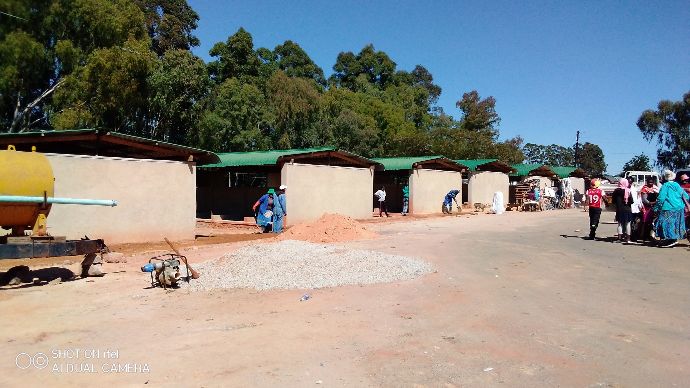
Nyamhuka 1 flea Market sheds under construction.

